**REVERSIBLE DATA-HIDING SCHEME:-** In the reversible scheme, a pre-processing is employed to shrink the image histogram, and then each pixel is encrypted with additive homomorphic cryptosystem by the image provider. When having the encrypted image, the data hider modifies the cipher text pixel values to embed a bit-sequence generated from the additional data and error-correction codes. Due to the homomorphic property, the modification in encrypted domain will result in slight increase/decrease on plaintext pixel values, implying that a decryption can be implemented to obtain an image similar to the original plaintext image on receiver side.  
Note that the data extraction and content recovery of the reversible scheme are performed in plaintext domain, while the data extraction of the previous lossless scheme is performed in encrypted domain and the content recovery is needless.

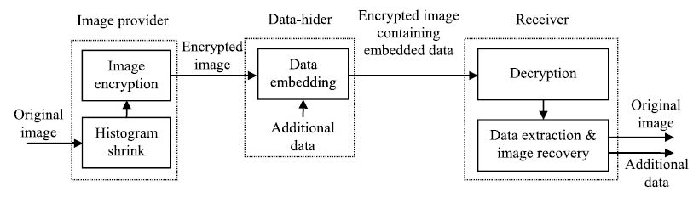

1. **Histogram Shrink and Image Encryption**:-In the reversible scheme, a small integer δ shared by the image provider, the data hider and the receiver will be used, and its value will be discussed later.

The image provider also divides all pixels into two sets: the first set including (N −8) pixels and the second set including the rest 8 pixels, and maps each bit of BS1, BS2 , and the LSB of pixels in the second set to a pixel in the first set with gray value V . Since the gray values close to extreme black/white are rare, there is

hV≥ l1 + l2 + 16.